**­­­­**

**Computer Systems ­ NVL INSTITUTE**

|  |  |
| --- | --- |
| Practical portfolio  Presented By Name……… |  |



**NCC Education**

**LEVEL 4 DIPLOMA IN COMPUTING**

**COMPUTER SYSTEMS**

|  |
| --- |
| Centre Name : NVL INSTITUTE  Assignment Title : PRACTICAL PORTFOLIO  Exam Cycle : DECEMBER 2018  Candidate Name : XXXXXXXXXX  NCC Education ID No : XXXXXXXXX  Submission Date : 31. Oct.2018 |
| Marker’s Comments :  Moderator’s Comments :  Mark: Moderated Mark: Final Mark: |



**Statement and Confirmation of Own Work**

***Each time you submit an assignment you must attach this statement as the cover page for both the hard copy and the electronic version. If the statement is missing, your work will not be marked.***

**Student Declaration**

I have read and understood NCC Education’s Policy on Academic Dishonesty and Plagiarism.

I can confirm the following details:

**Programme/Qualification Name** : Level 4 Diploma in Computing

**Student ID/Registration Number** : XXXXXXX

**Name**  : XXXXXXXXX

**Centre Name** : NVL INSTITUTE

**Module Name**  : COMPUTER SYSTEMS

**Module Leader** : U MIN THU KHANT

**Number of words** :

I confirm that this is my own work and that I have not plagiarized any part of it. I have also noted the assessment criteria and pass mark for assignments.

**Due Date** : 31. Oct.2018

**Student Signature**  : Sign

**Submitted Date** : 31. Oct.2018

Contents

INTRODUCTION 1

ACKNOWLEDGEMENT 1

Task1-Windows Installation 1

1. Installation of Windows XP Professional SP2 1

a. Identification of key stages in the Windows XP Professional Installation. 1

b. Identification and description of required device drivers and their source locations. 1

c. Identification and description of unresolved issues – especially missing device drivers. 1

2. Installation of antivirus software 1

a. Identification of product used. 1

b. Identification and description of key stages in installation. 1

c. Identification and description of problems and unresolved issues. 1

d. Outline of the update process for the antivirus software. 1

3.Installation of office software 1

a. Identification of product used. 1

b. Identification and description of key stages in installation. 1

c. identification and description of problems and unresolved issues. 1

4.Installation of free utility 1

a. Identification of utility, outline of what it does and reason why you chose this (make it different from that of your classmates). 1

b. Identification and description of key stages in installation. 1

c. Identification and description of problems and unresolved issues. 1

Task2- Linux Installation 1

1. Installation of Linux 1

a. Identification of distribution 1

b. Description of disk partitioning (e.g. partition options, partition size). 1

c. Identification and description of required device drivers and their source locations. 1

d. Description of setting up administrator and standard user. 1

e. Description of network set-up. 1

f. Identification and description of installation process for one application. 1

2.Testing of Linux system 1

(a) Identification of test plan for system. 1

(b)Record of how system performance against test plan 1

Task3-Faulty PCs 1

1.The steps that you followed to identify the fault. 1

2.Cause of the Fault. 1

3.The steps taken to remedy the fault. 1

4. The success or failure of the repair. 1

1.The steps that you followed to identify the fault. 1

2.Cause of the Fault. 1

3. The steps taken to remedy the fault. 1

4. The success or failure of the repair. 1

CONCLUSION 1

REFERENCE 1

# INTRODUCTION

My name is Thet Naing Soe. I attended the Level (4) diploma in computing in NVL institute at Mandalay. I studied Four subjects. They are Skill for computing, Standard development Techniques, Computer Network and Computer System. This assignment is Computer System.

# ACKNOWLEDGEMENT

First, I want to appreciate to NCC Education for learning the computing and I would like to thanks for getting knowledge from my school, NVL institute.

Thank you very much to my subject lecturer U Min Thu Khant, class coordinators who support to me and my friends who discuss for this assignment with me.

TASK-1

# Task1-Windows Installation

## 1. Installation of Windows

### a. Identification of key stages in the installation

Firstly, out of many choices I choose to install window (8).In order to understand it will as the language, time and currency and input method.

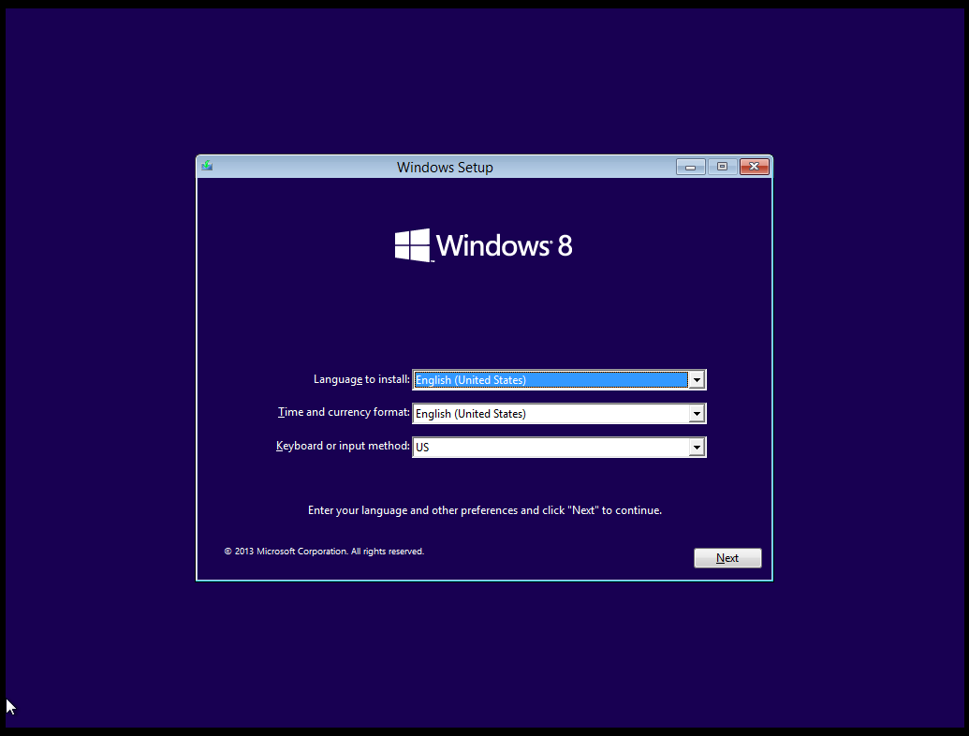

After clicking the next button, window(8) set up box will drop down.

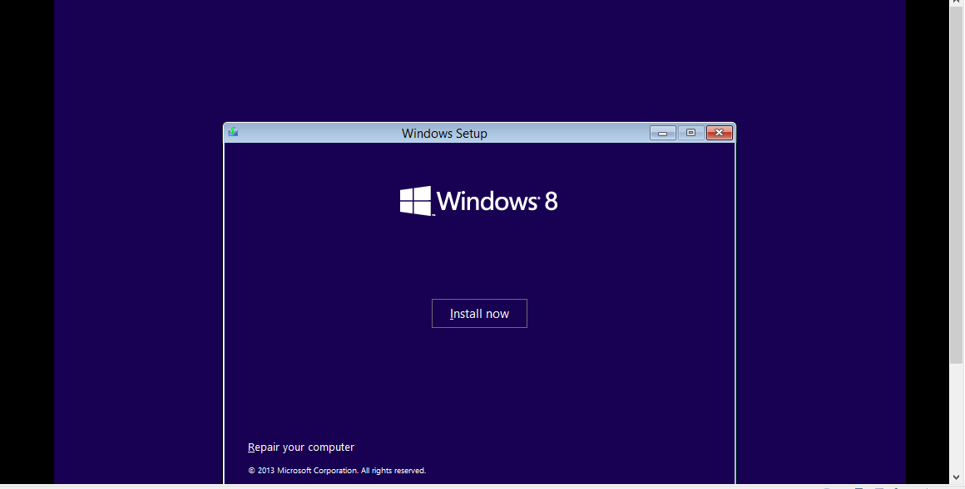

Then it asks us the product key so that we can continue activating the windows.

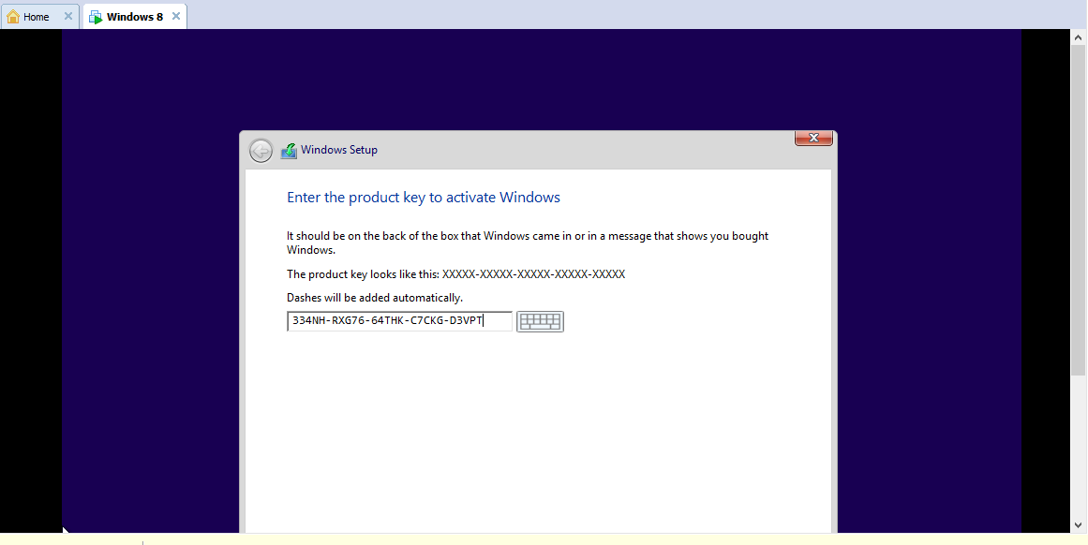Then we have to choose the partition.

t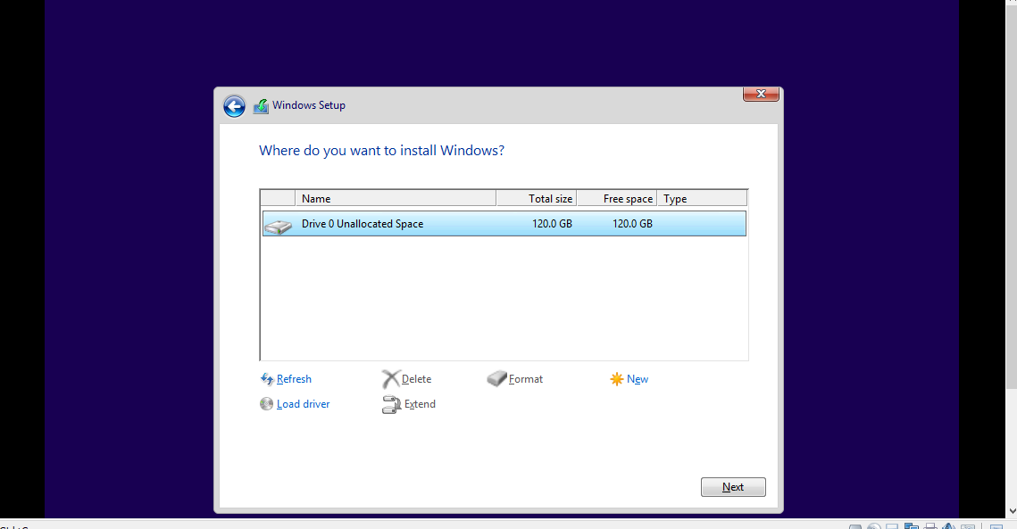

In the next step, we have to separate the partition into two pieces.

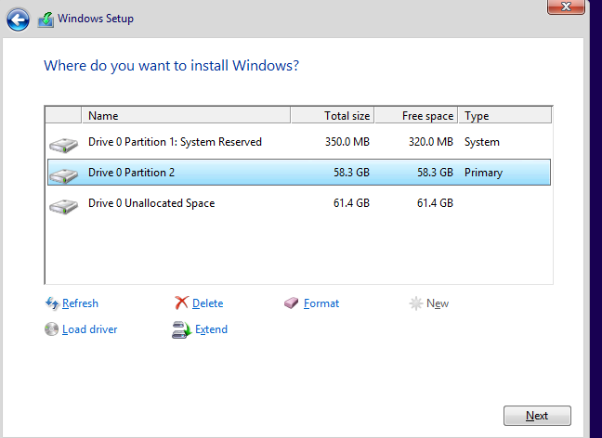In order to continue installing, we have to agree to the window license terms.

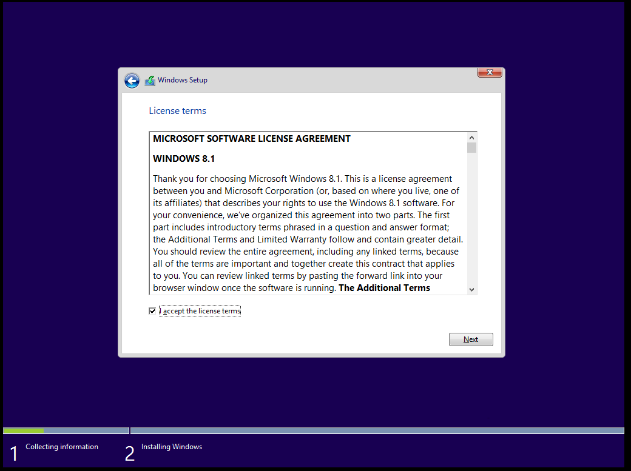

By looking, we can know the install license.

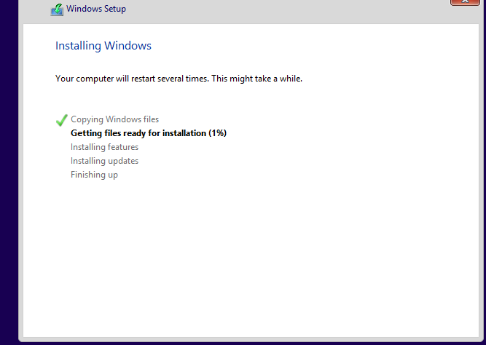

Now the window (8) is ready to install.



Now we have to personalize the computer by choosing the PC name and background colour.

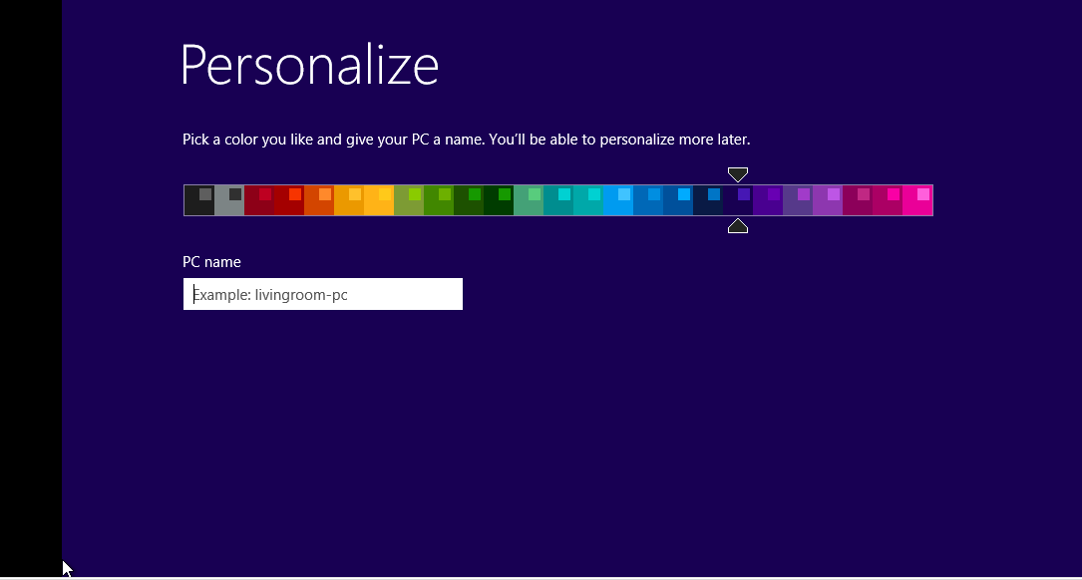

Now we have to customize the Microsoft by using express setting.

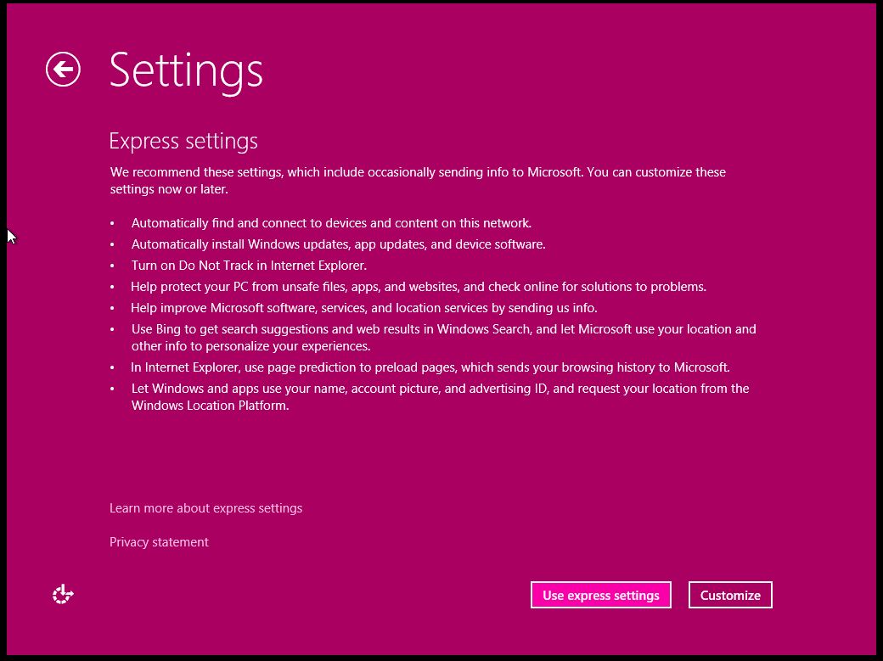

Now, we have to create account.

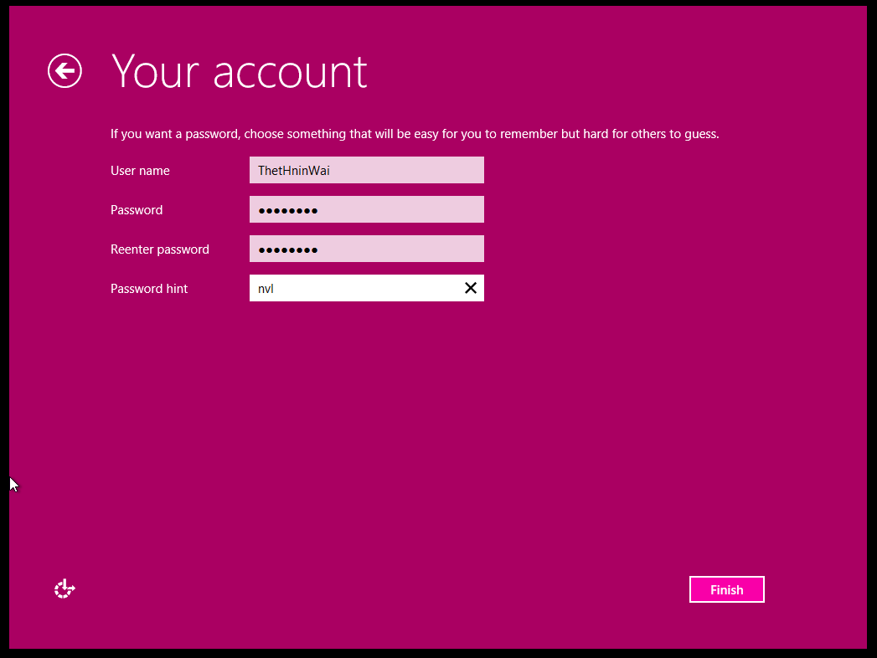

.

Then we see this figure.

In then next step we will find another figure.



Window is almost ready.

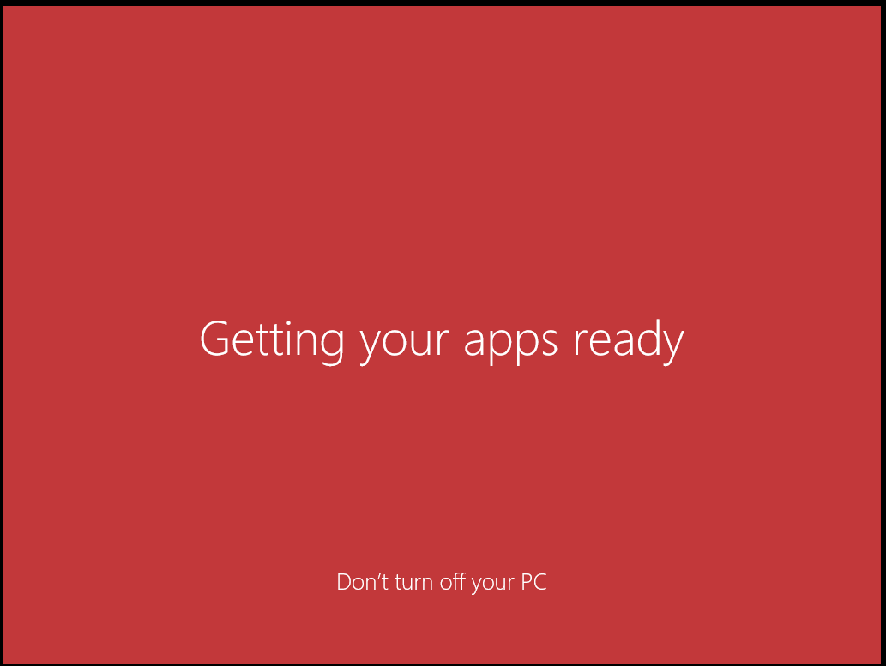

The window (8) installation is going to finish.

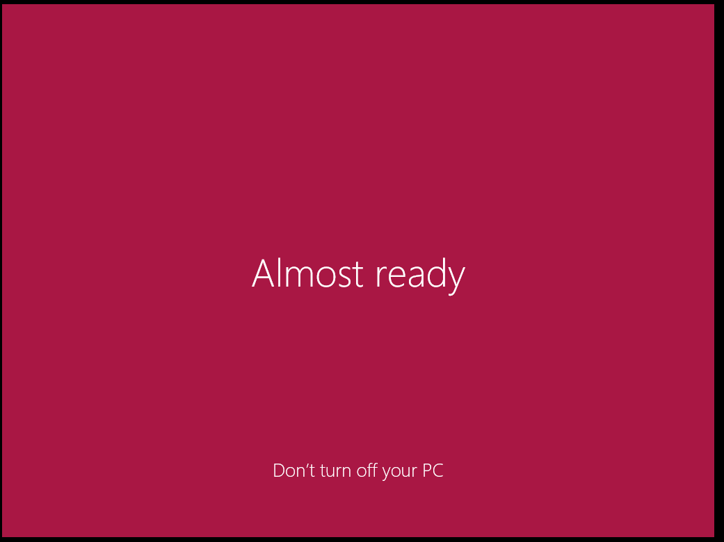

The window (8) is finish.



### b. Identification and description of required device drivers and their source locations.

Fig(1.1b.8)

### c. Identification and description of unresolved issues – especially missing device drivers.

## 2. Installation of antivirus software

### Identification of product used.

everybody needs antivirus software. Computer viruses don’t just come from streaming or downloading movies. Many people think that they can avoid potential threats by making sure they don’t visit certain websites or download certain files. You often have three options when faced with a threat on your computer: delete the threat, quarantine it or ignore it. Most antivirus software works on a signature database, monitoring the internet 24 hours a day, 7 days a week. Every time a new virus is reported – it’s indexed, catalogued and added to the software’s database. Once your antivirus software is up-to-date it is equipped to tackle the new virus should it ever reach your device.

### b. Identification and description of key stages in installation.

In First stage, We clip continue.

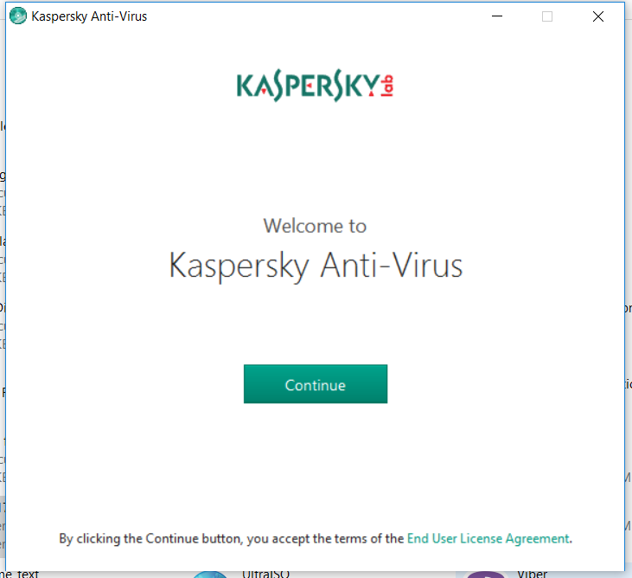

In second stage include everything is ready for installation and we clip install button.

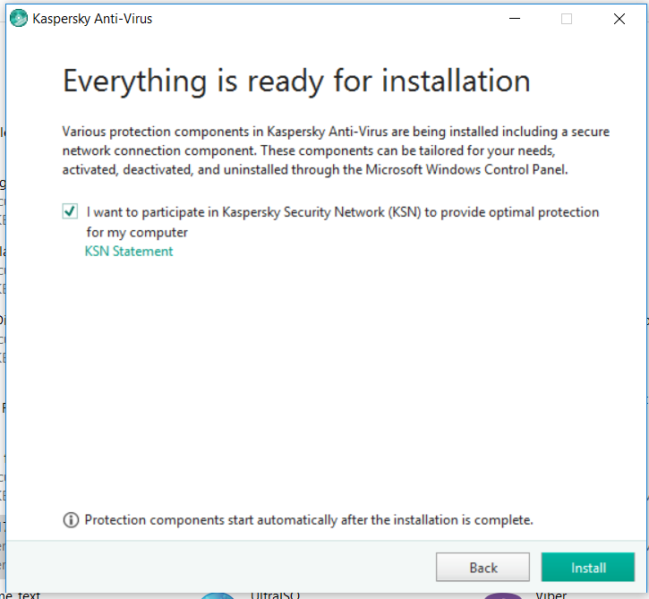

In third stage include hard drive on this computer and click No button.

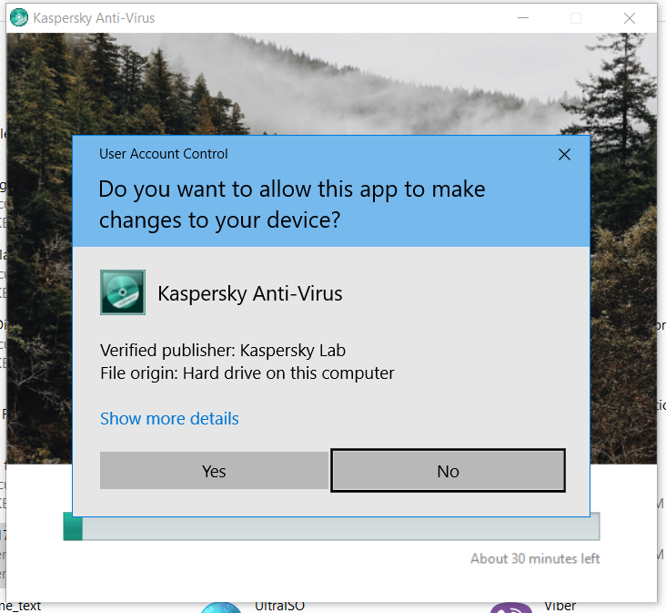

In four stage include downloading the application.

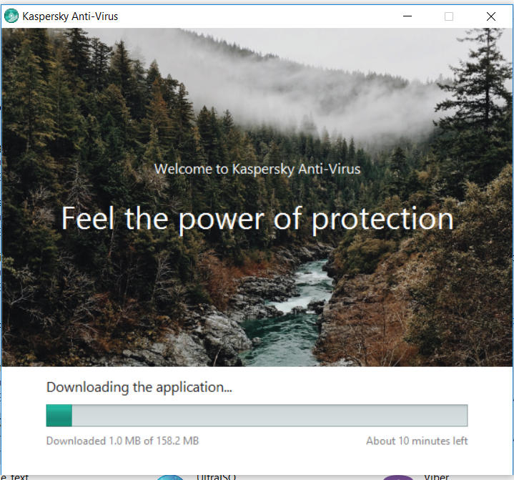

In five stage include the application has been installed successfully and we clip Done.

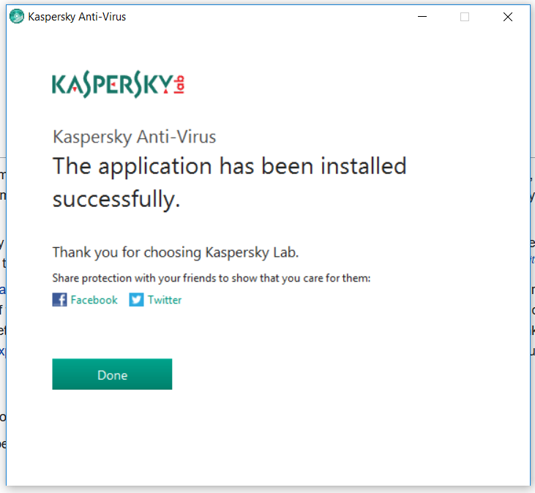

In six stage include Kaspersky anti- Virus and we clip continue.

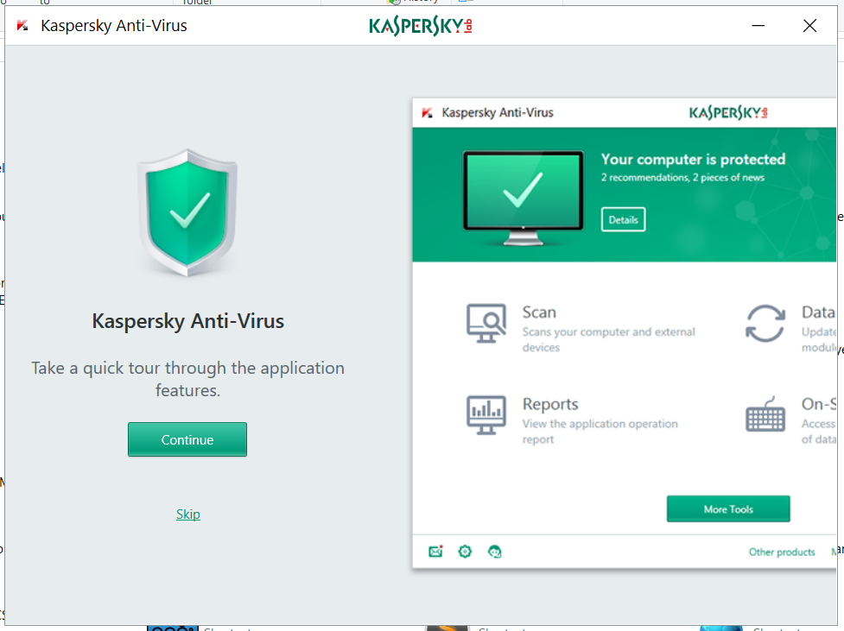

In seven stage include files are protected and we clip Next button.

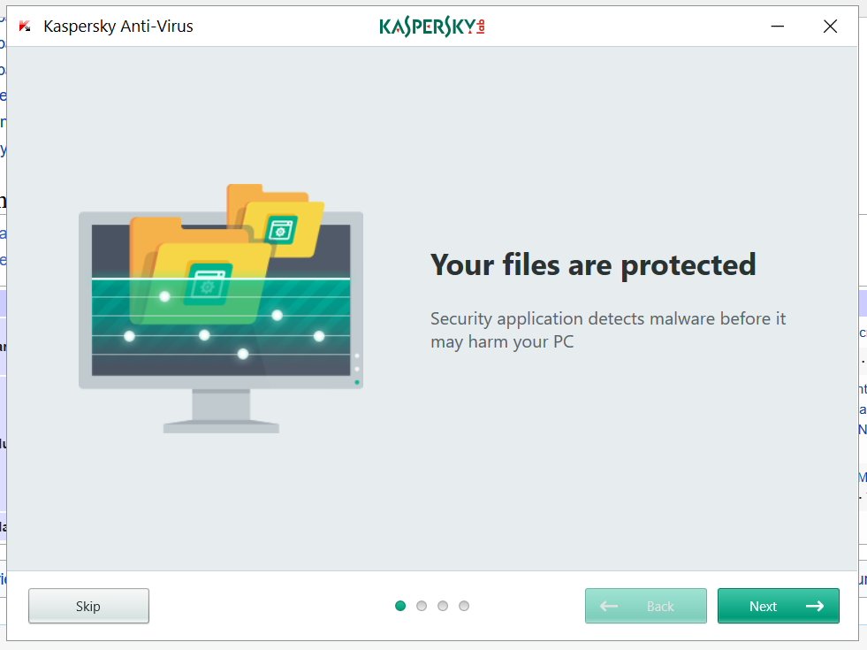

In eight stages include on screen keyboard and we clip Next Button.

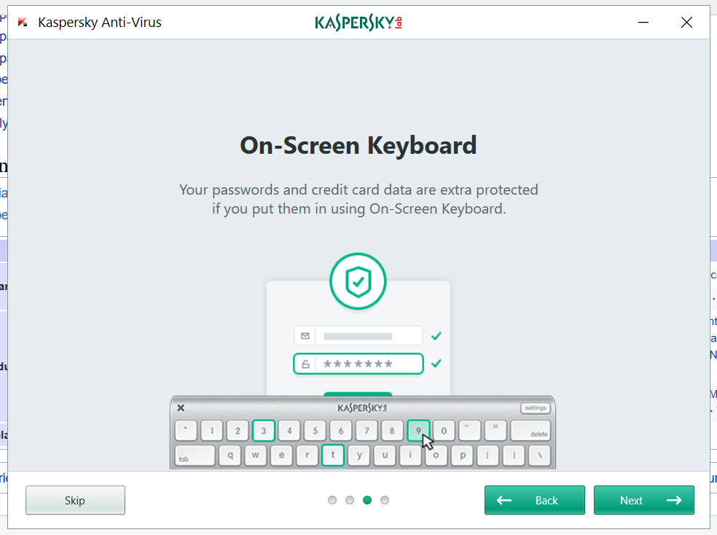

In nine stages include the power protection and we clip Done.

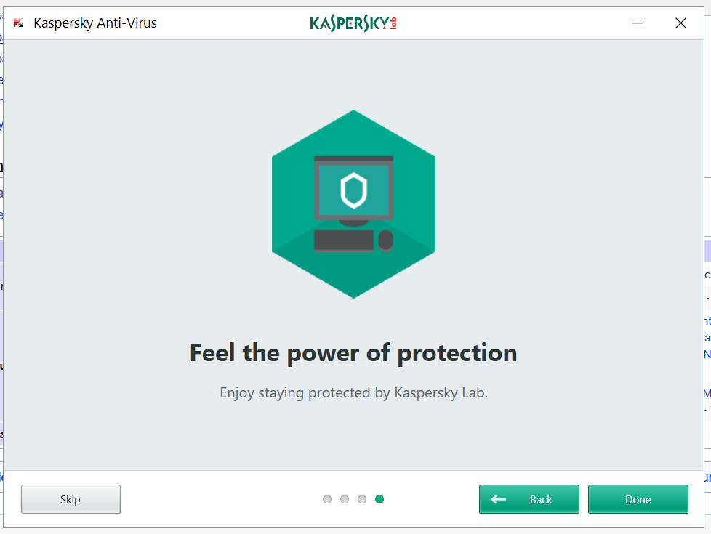

In ten stages include instant response to threats and we clip Next button.

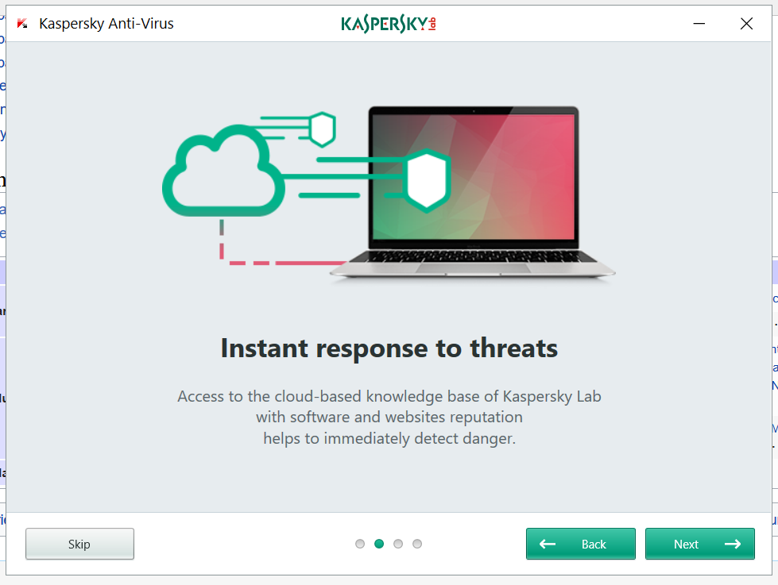

In finally stages, We can be use Kaspersky Anti- virus software.

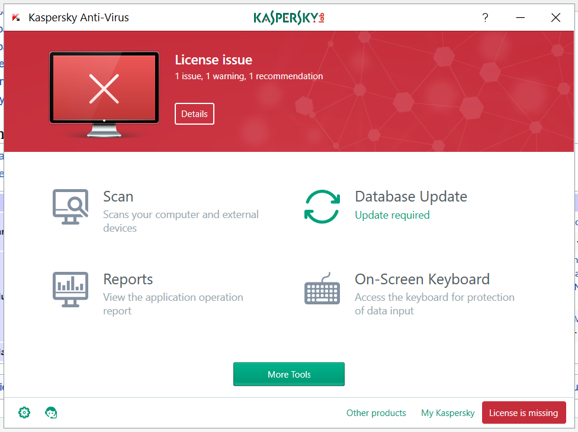

### c. Identification and description of problems and unresolved issues.

This is a FIX Kaspersky error.



Fig(1.2c.1)

### d. Outline of the update process for the antivirus software.

This is a security error in the antivirous software.

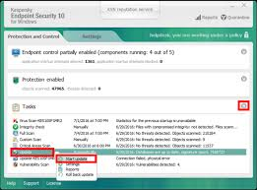

Fig(1.2d.1)

## 3.Installation of office software

### a. Identification of product used.

Microsoft Office 2016 (codenamed Office 16) is a version of the Microsoft Office productivity suite, succeeding both Office 2013 and Office for Mac 2011. It was released on macOS on July 9, 2015 and on Microsoft Windows on September 22, 2015 for Office 365 subscribers. Mainstream support ends on October 13, 2020, and extended support ends on October 14, 2025. The perpetually licensed version on macOS and Windows was released on September 22, 2015. Since its successor Office 2019 only supports Windows 10 or Windows Server 2016, this is the last version of Microsoft Office compatible with Windows 7, Windows Server 2008 R2, Windows 8, Windows 8.1, Windows Server 2012, and Windows Server 2012 R2

### Identification and description of key stages in installation.

First stage, in my files, I choose office 16.exe to start install in my laptop this assignment.

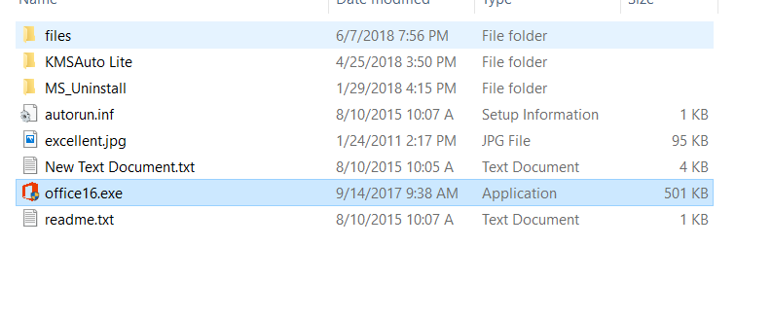

Fig(1.3b.1)

Second stage, Office 16.exe interrogative me if I wanted to approves this application feasible changes in my laptop.

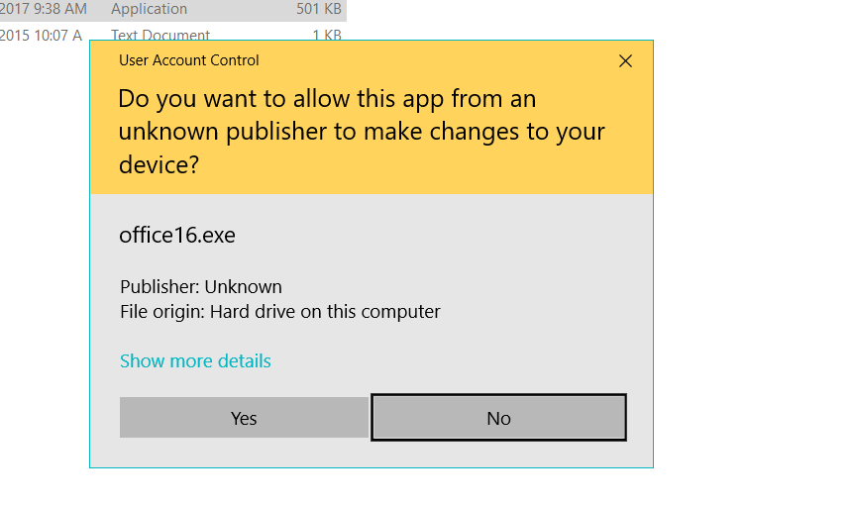

Third stage, I have to choose that application that I wanted have this installation.

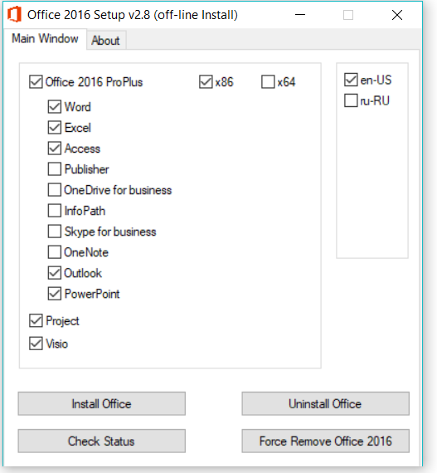

Fourth stage, That application is loading to get the ready.



Step 5

Fifth stages , the office 2016 is install to ready.

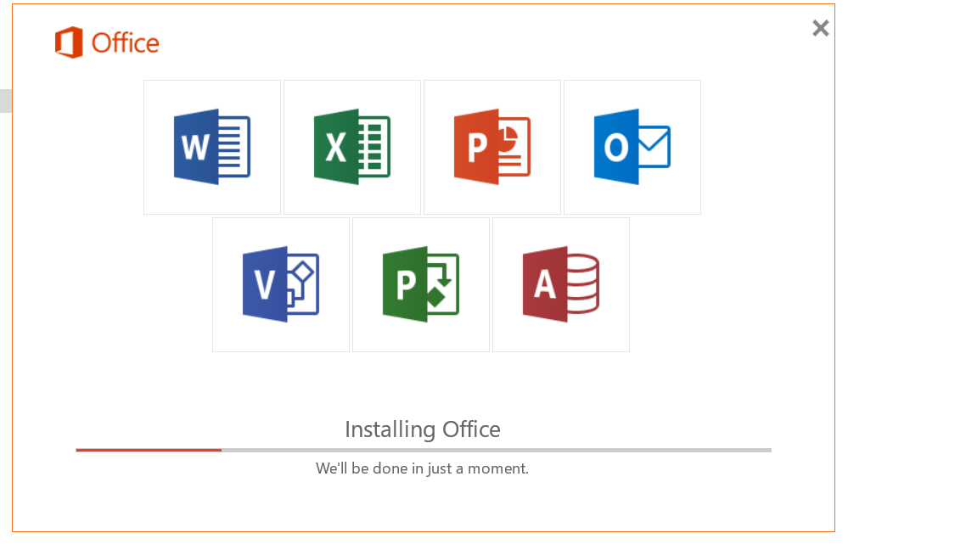

Step 6

The last stage, The office 2016 is installing my laptop.

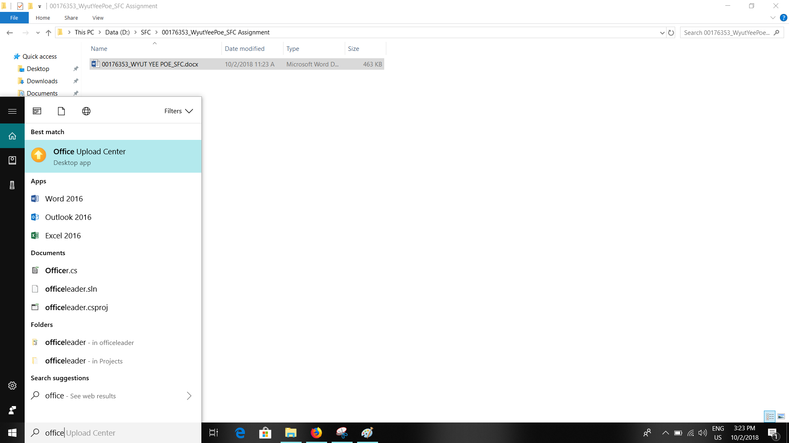

### identification and description of problems and unresolved issues.

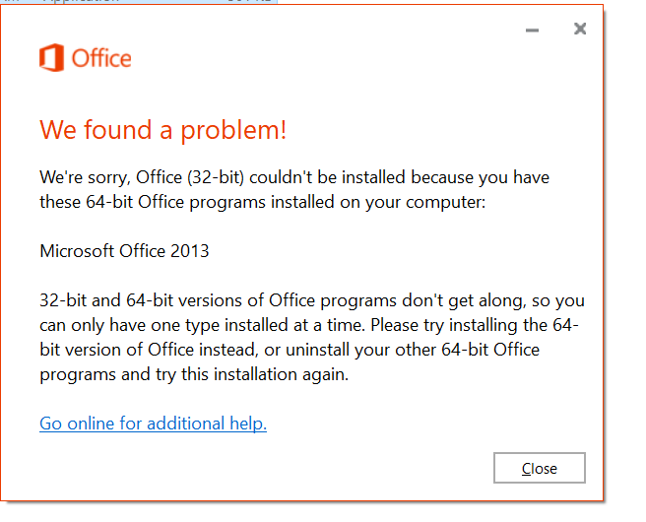

Fig(1.3c.1)

## 4.Installation of free utility

### a. Identification of utility, outline of what it does and reason why you chose this (make it different from that of your classmates).

C Cleaner benefit of two main types. First stage, C cleaner can scan it scans deletes useless files and freeing up space. Second stages, C Cleaner abolishing searching data like your browsing history and list of most recently other virous program files. C cleaner protects to good your privacy. C Cleaner is not a big. Effective utility for computers running Microsoft Windows that cleans out the 'junk' that accumulates over time: temporary files, broken shortcuts, and other problem from various programs saving. C Cleaner cleans inessentials your hard disk space Vacantness and remove unneeded ingress.

### b. Identification and description of key stages in installation.

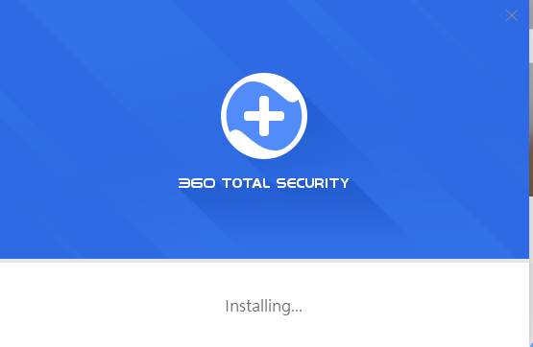

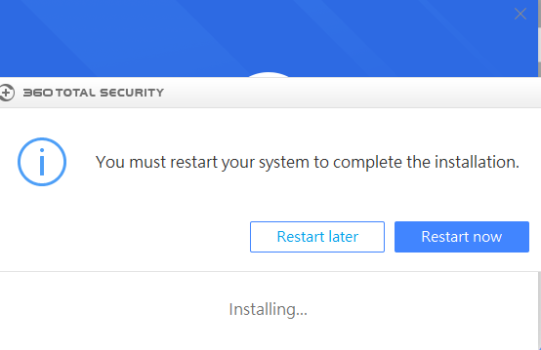

Fig(1.4b.1)

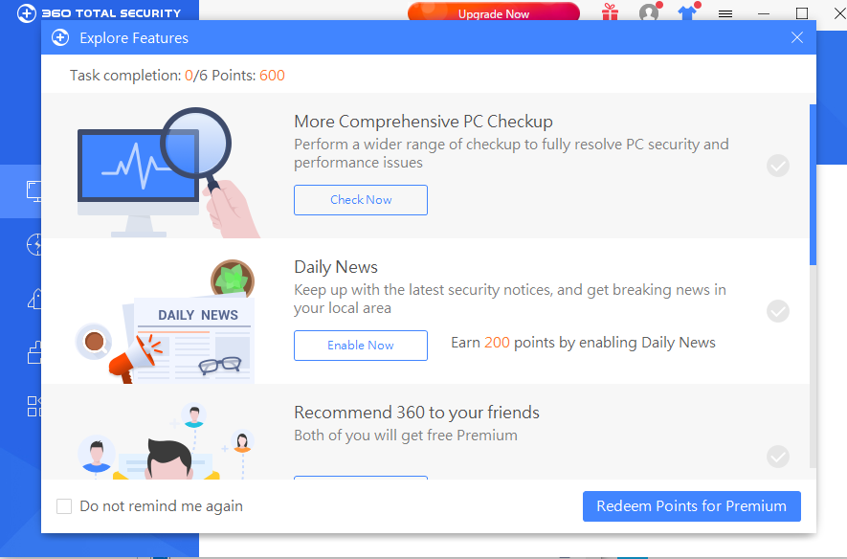

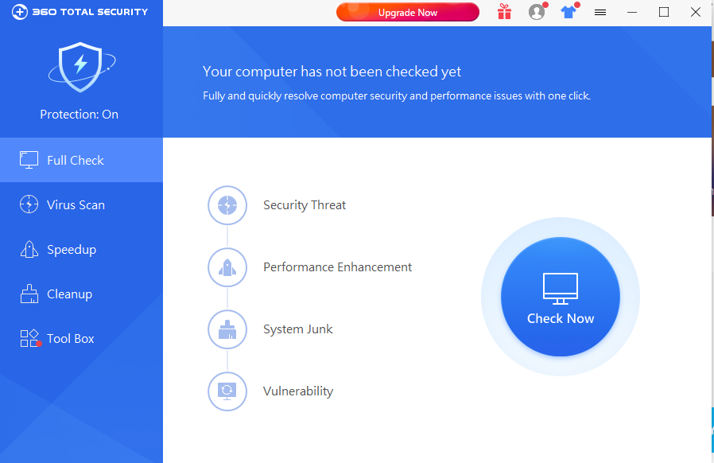

### c. Identification and description of problems and unresolved issues.

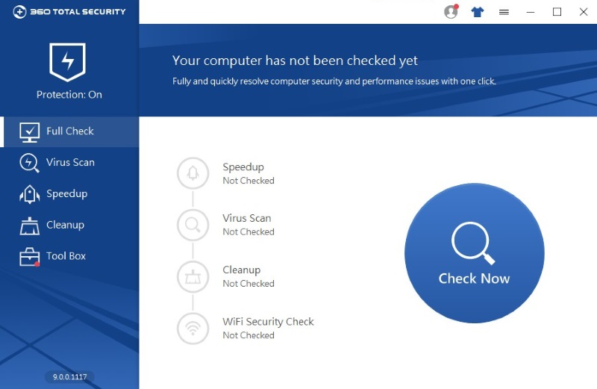

Fig(1.4c.1)

**Topic 5: Laboratory Supervisor Sign Off**

|  |  |  |
| --- | --- | --- |
| Student Name | Name |  |
| Student ID | ID |  |
| Student Signature | Sign |  |
| Laboratory Supervisor Name | DAW AYE SANDAR TUN |  |
| Laboratory Supervisor Signature | Sandar |  |
|  |  |  |
| Task | Degree of Completion (to be completed by supervisor) | Completed (Signed Laboratory Supervisor) |
| Installation of Windows   1. Installation of Windows 7 2. Device driver and drivers and their source location. 3. Unresolved issues- especially missing driver | Window XP and Device Driver Installation | Successfully |
| Installation of Anti-Virus   1. Identification of Product 2. Key stages of installation 3. Update Process 4. Unresolved issue | Kasper Antivirus | Successfully |
| Installation of Office Tools   1. Identification 2. Key stages of installation 3. Description of problems | Microsoft office 2007 | Successfully |
| Installation of Utility   1. Identification of Utility 2. Key stages of installation 3. Description of problem | USB Disk Security | Successfully |

TASK-2

# Task2- Linux Installation

## Installation of Linux

### Identification of distribution

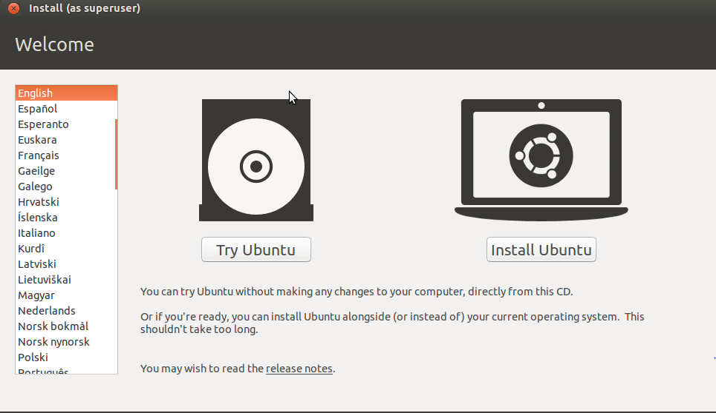

Fig(2.1a.1)

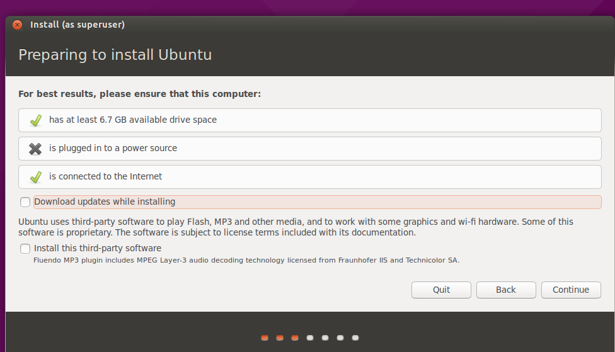

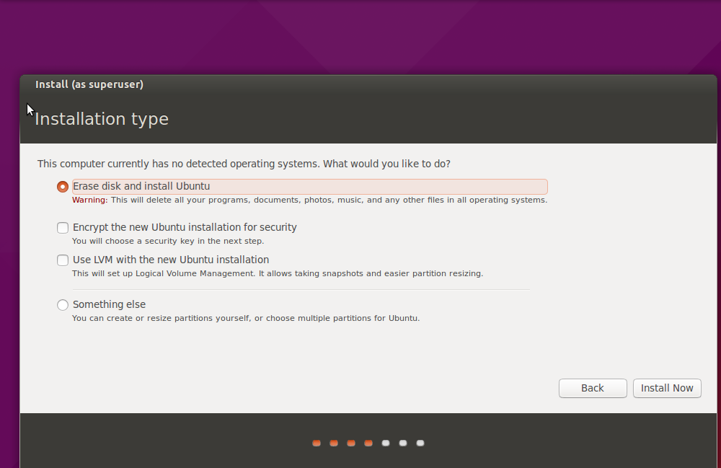

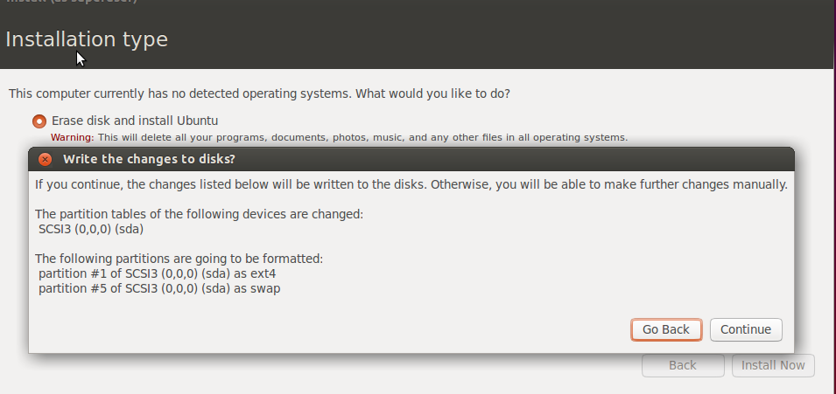

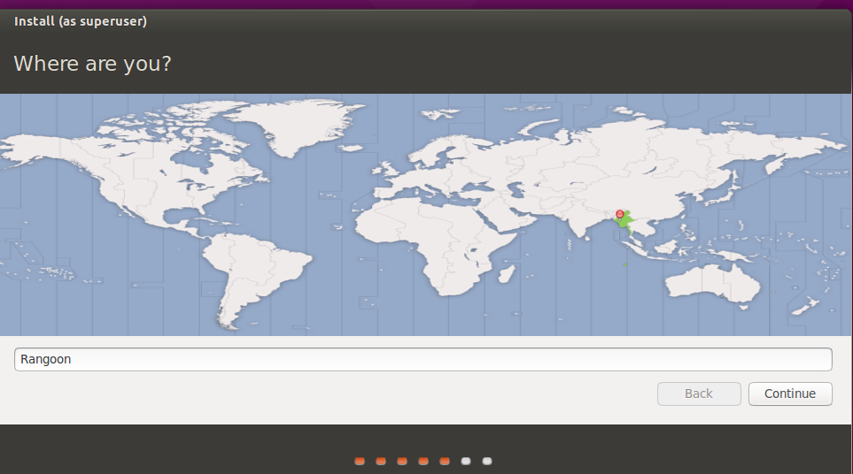

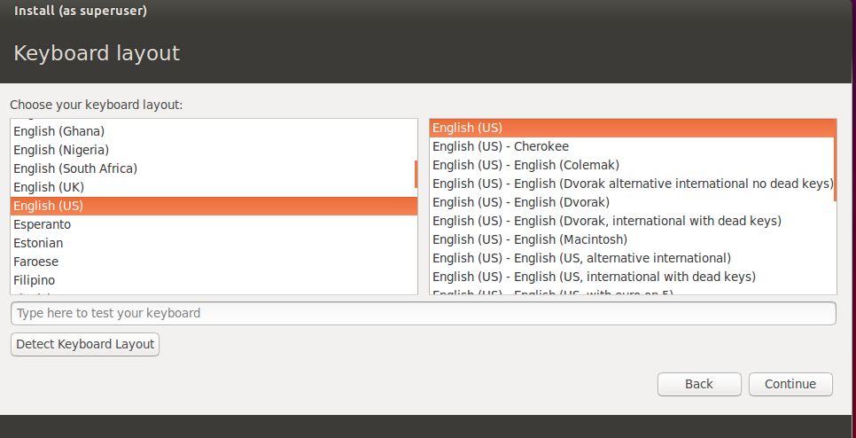

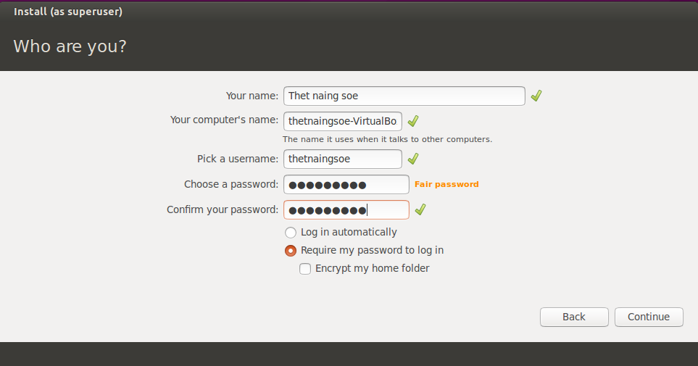

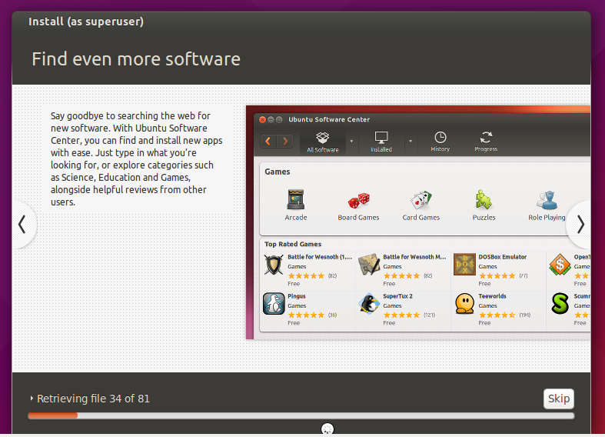

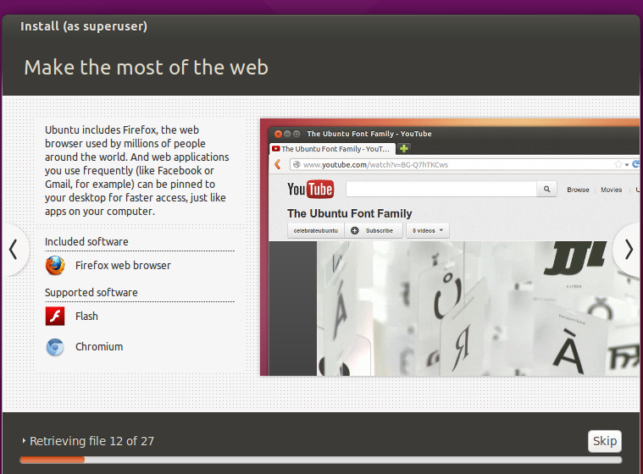

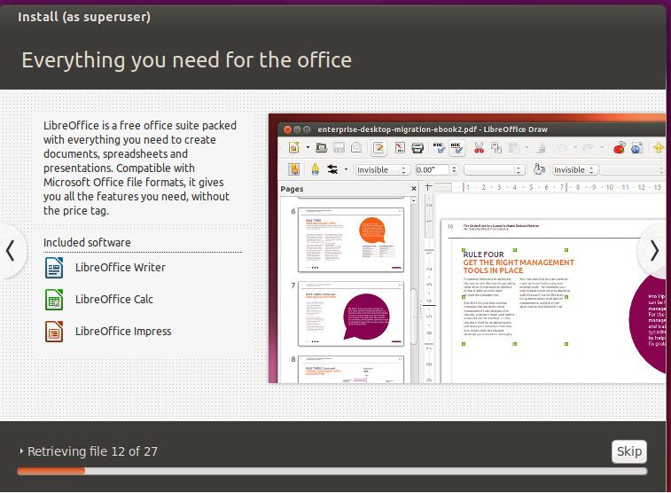

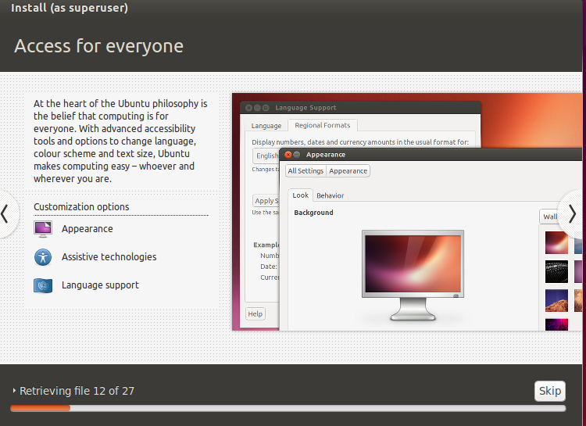

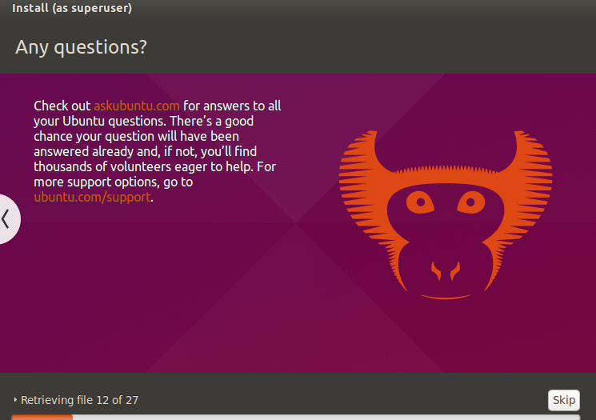

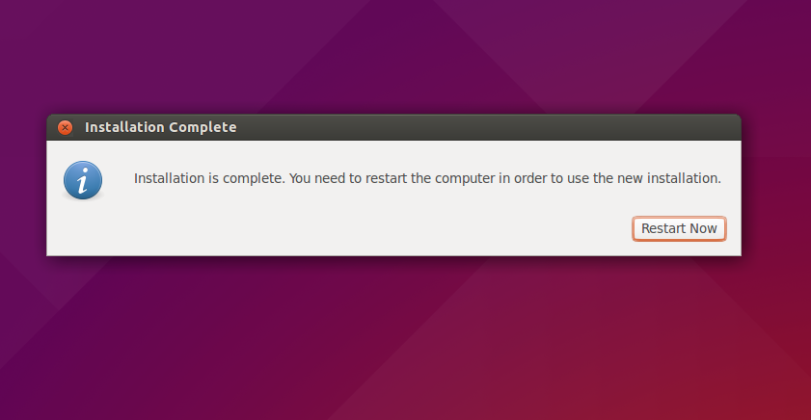

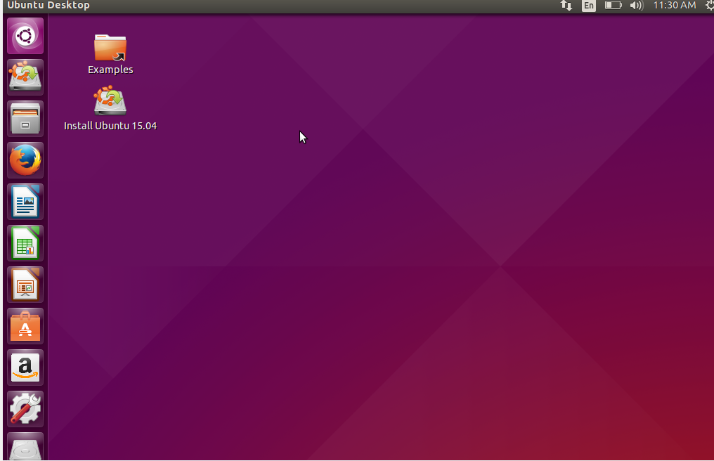



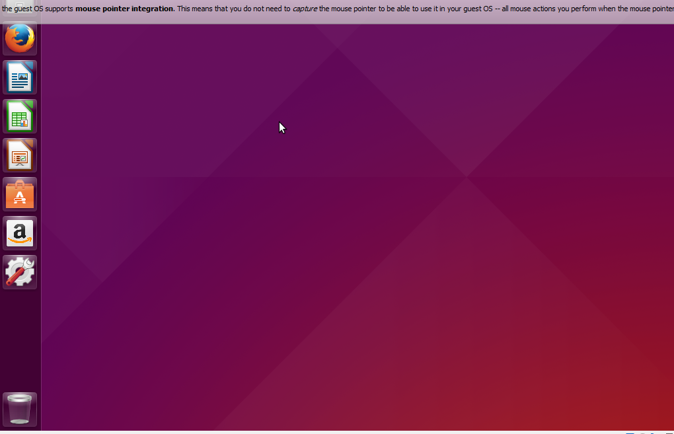

### Description of disk partitioning (e.g. partition options, partition size).

First stage, I choose the something else.

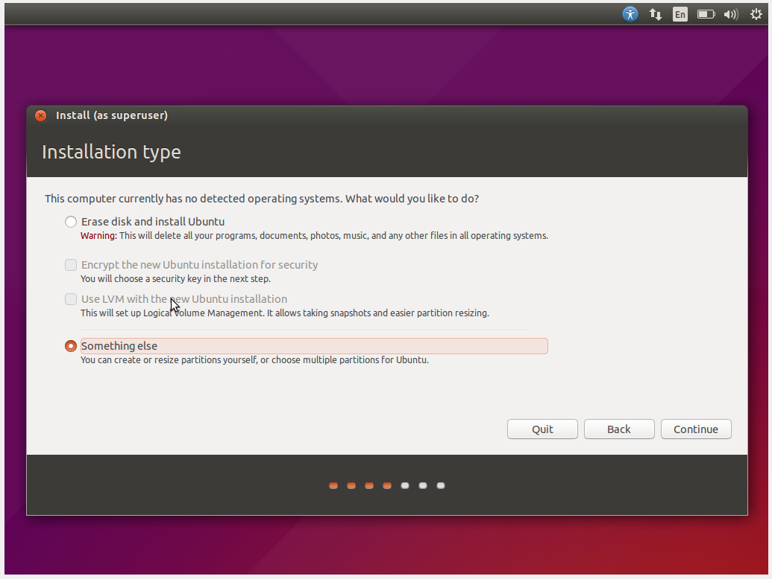

Fig(2.1b.1)

Second stage, is part ion step. I can choose somethings else for partion.

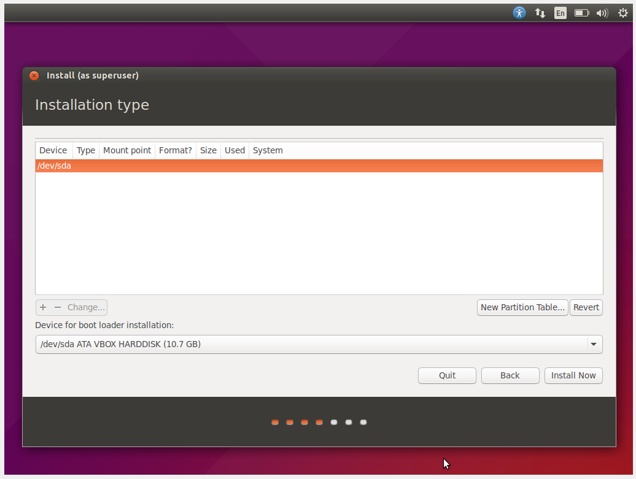

Third stage, click to continue for new empty portion .

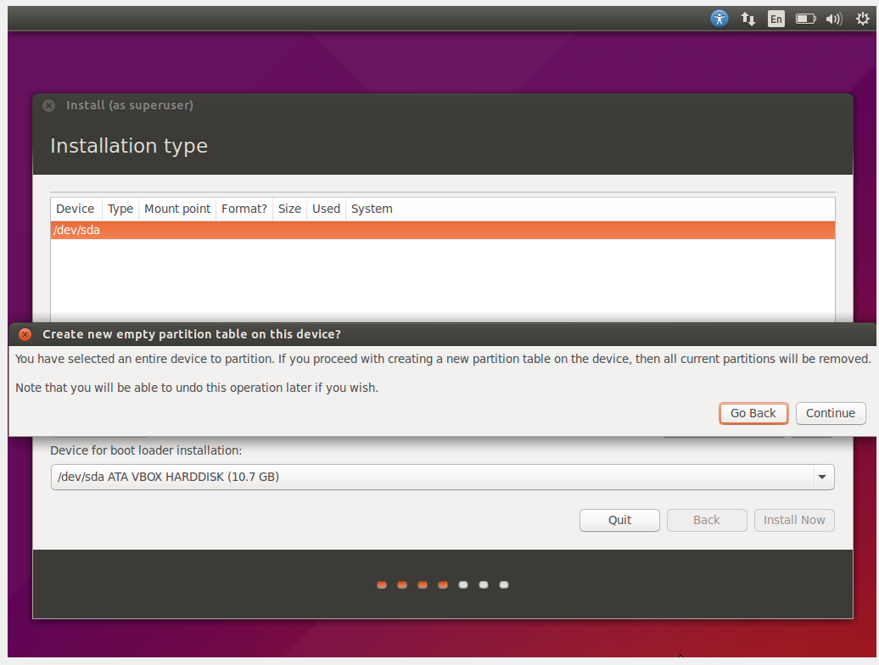

Fourth stage, we click free space and then partion half by half in the size.

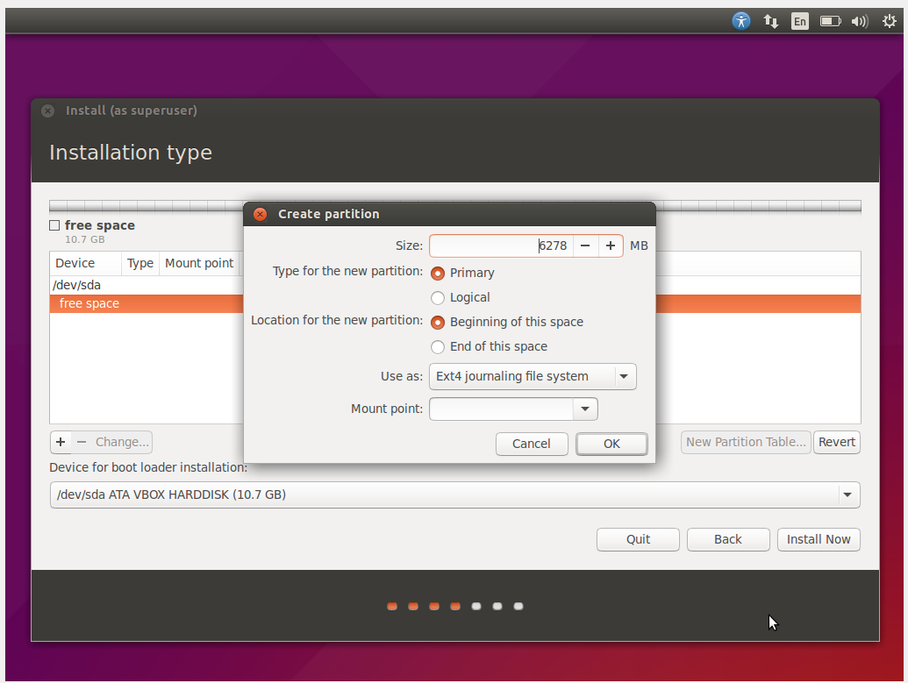

Fifth stage, we double click pre-divided dev/sdal ext4.

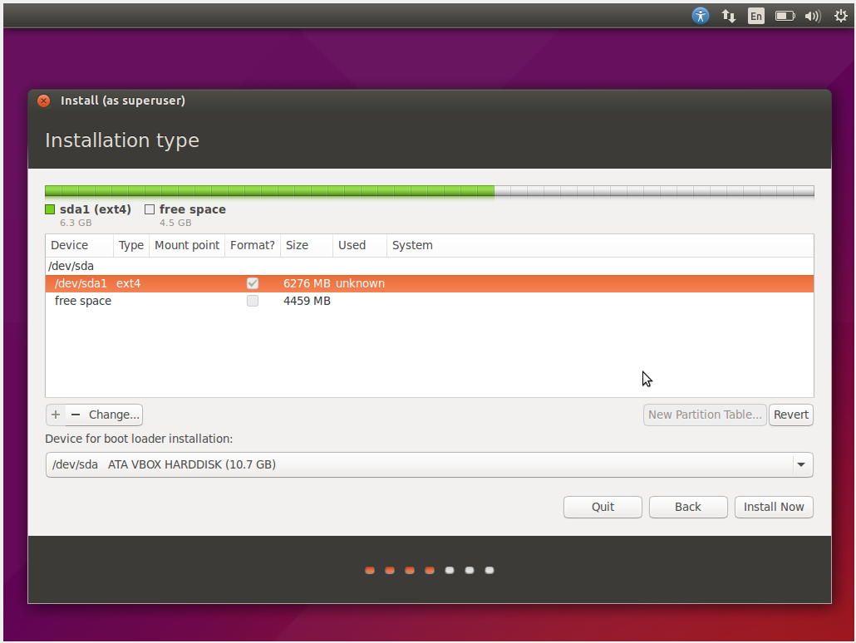

### Identification and description of required device drivers and their source locations.

First stage, I choose the additional driver.

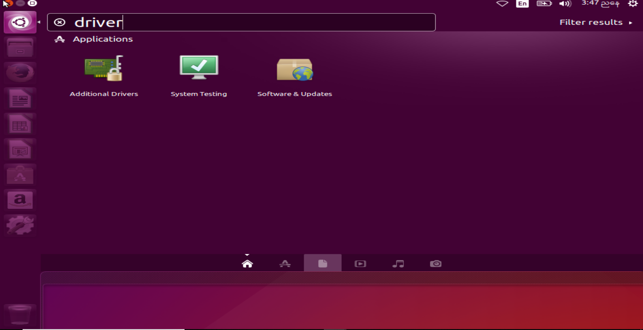

Second stage, I choose the using process microcode fireware for intel CPUS from intel-microcode.

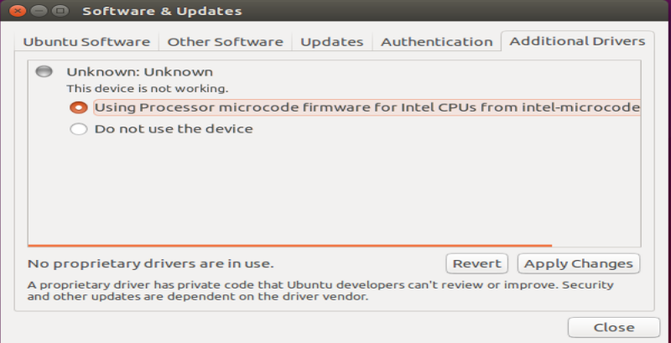

Third stage, we give a password.

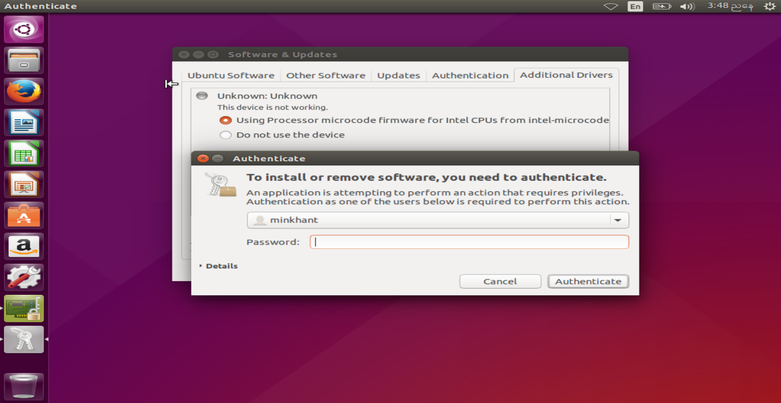

Final stage, we click additional driver. Therefore, the following box is drop.

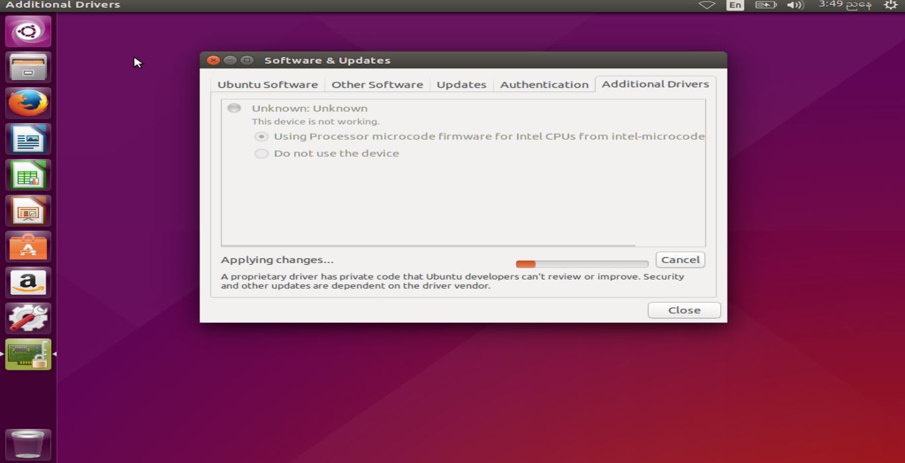

Fig(2.1c.1)

### Description of setting up administrator and standard user.

First stage, we will write my password in the textbox button.

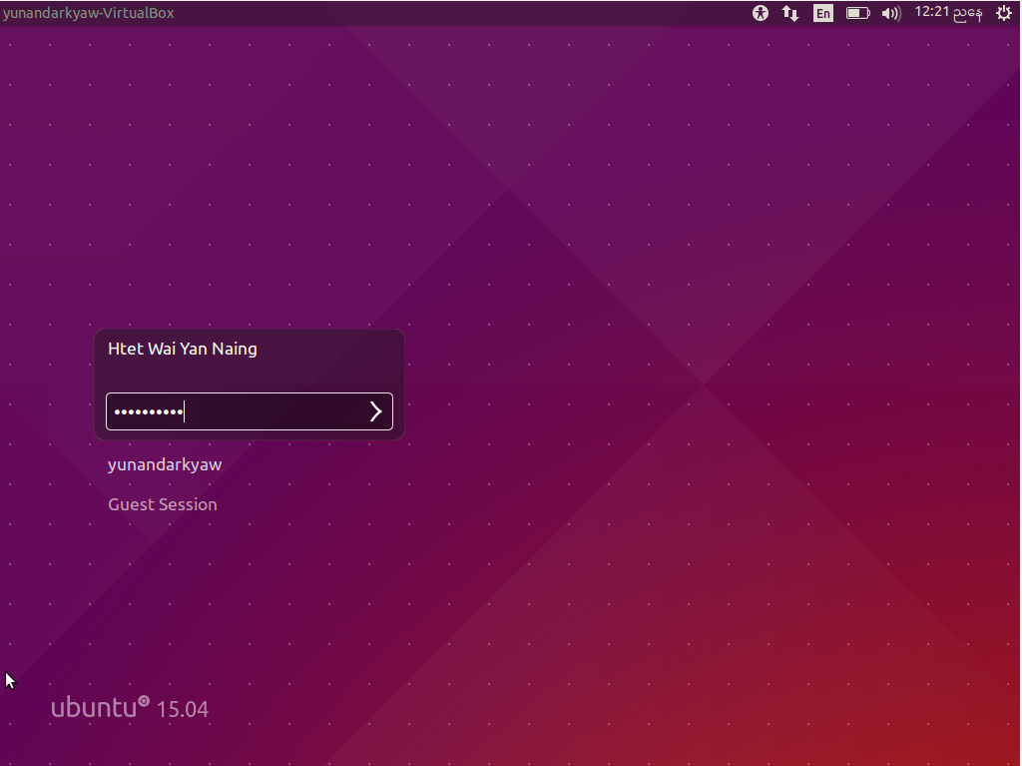

First stage, to create a user account, we give a password to do for user account.

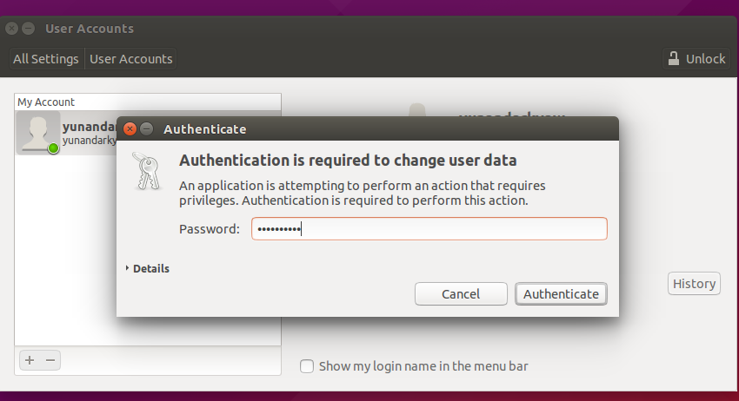  
Second stage, I choose a standard account title, Full name is Htet wai Yan Naing and I click add function.

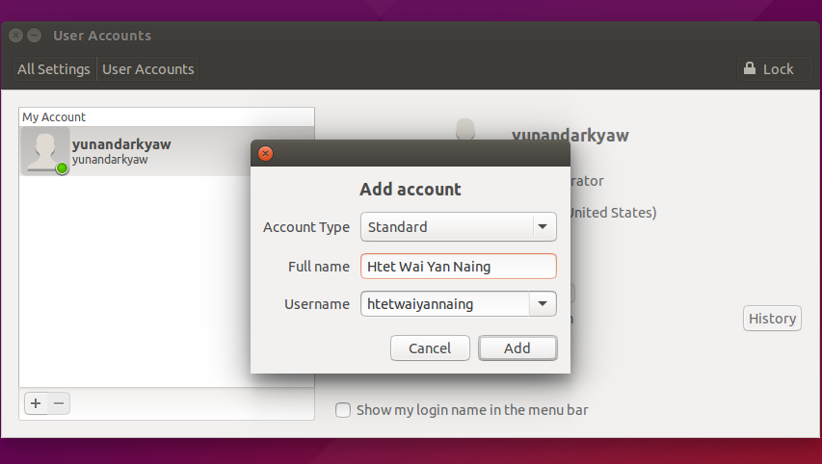

Fig(2.1d.1)

Third stage, it is a Htet Wai Yan Naing standard account.

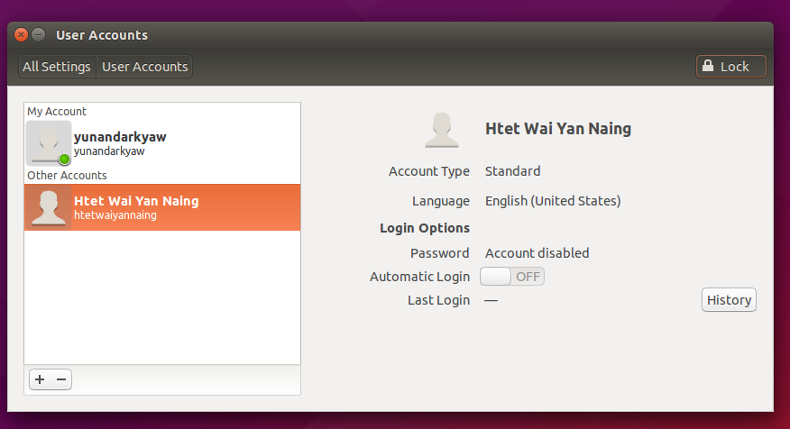

Four stage, we will write my password in the textbox button.

Five stage, we will build standard account by clicking ‘+’sign button and I will give Full name and Username.

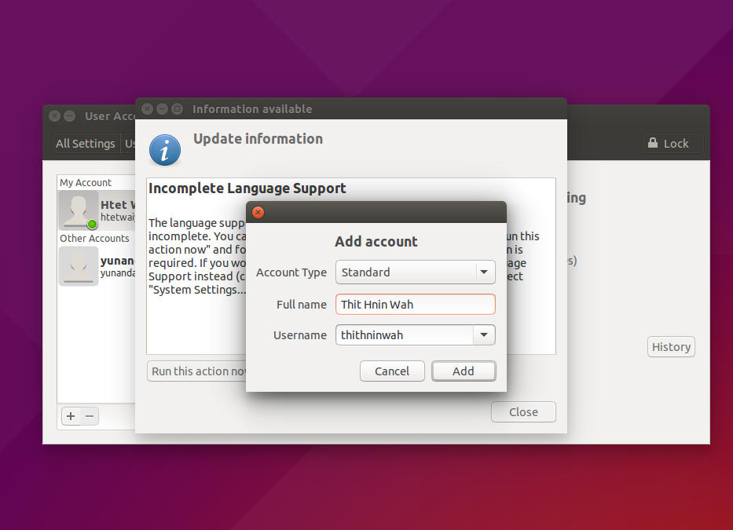

Six stage, When we clicked ‘ Add’ button, this figure is drop down.

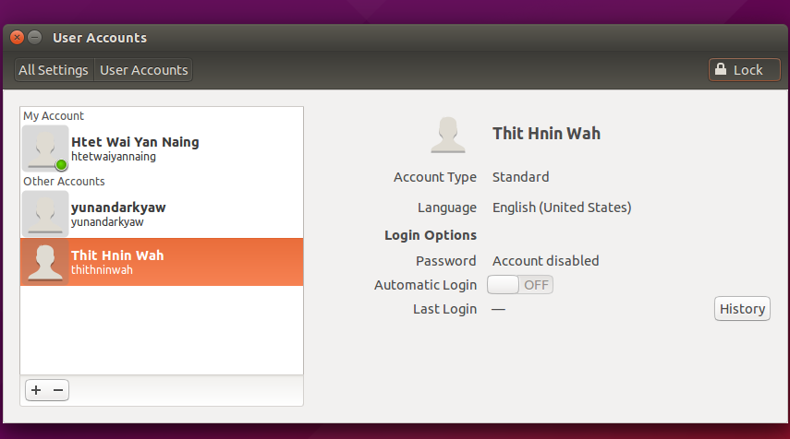

### Description of network set-up.

Fig(2.1e.1)

### f. Identification and description of installation process for one application.

Fig(2.1f.1)

## 2.Testing of Linux system

### (a) Identification of test plan for system.

### (b)Record of how system performance against test plan

Fig(2.2b.3)

**Topic 6: Laboratory Supervisor Sign Off**

|  |  |
| --- | --- |
| Student Name | Name |
| Student ID | ID |
| Student Signature | **Sign** |
| Laboratory Supervisor Name | DAW AYE SANDAR TUN |
| Laboratory Supervisor Signature | **Sandar** |
|  |  |
| Test Demonstrated by Student | Degree of Completion (completed by laboratory supervisor) |
| Successfully Install a Linux | Completed Installation of Linux |
| Successfully Network Setting | Completed Installation of Network Setting |
| Using an Internet | Good using the internet |
| Using one application installed | Completed one application installed |
|  |  |
|  |  |
|  |  |
|  |  |
|  |  |
|  |  |
|  |  |
|  |  |
|  |  |
|  |  |
|  |  |
|  |  |
|  |  |

TASK-3

# Task3-Faulty PCs

## Error Name

### 

### 1.The steps that you followed to identify the fault.

When the computer is open, the operating is not work well and the follow errors is display on the black screen.

### 2.Cause of the Fault.

The error with this black screen is shown CPU fun error that cause by dusting of the fun or the bad CPU fun.

### 3**.The steps taken to remedy the fault.**

Open system box and clean CPU fun. And then, install again CPU fun and shutdown. The successful (or) failure of this error. If failure be need to change with a good new fun.

### 4. The success or failure of the repair.

After of replacing new fun the operating is work well that show. We are solving the of this error successfully.

# ERROR Name

### 1.The steps that you followed to identify the fault.

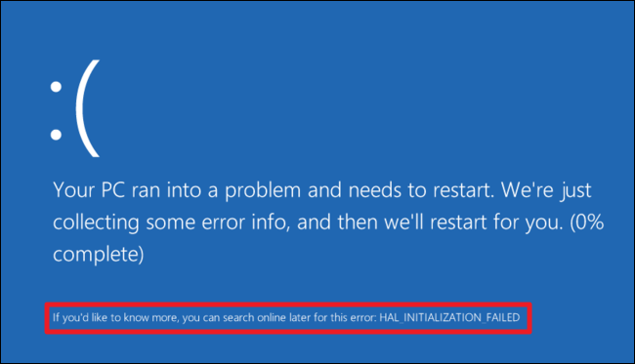

The Pc ran into a problem and needs to restart and just collecting some errors info, then we will restart for you and 0% complete.

### 2.Cause of the Fault.

When I resume my person computer blue screen error occur today. Dump memory is equal to the 100 by the error. Which I have not remember and very confused and I want help there was some technical information.

### 3**.The steps taken to remedy the fault.**

First stage, trying the easiest things is the system restore. System restore can undo

recent changes to me of the computer system files that might have caused the problem. Our person files such as email, documents, or photo.

### 4. The success or failure of the repair.

When my computer error, I can prepare system restore. The computer function run and it is success.

**Topic 7: Laboratory Supervisor Sign Off**

|  |  |  |
| --- | --- | --- |
| Student Name | NAME |  |
| Student ID | ID |  |
| Student Signature | Sign |  |
| Laboratory Supervisor Name | DAW AYE SANDAR TUN |  |
| Laboratory Supervisor Signature | **Sandar** |  |
|  |  |  |
| Faulty PC Number | Fault Found (to be completed by laboratory supervisor) | Fault Remedied (to be completed by laboratory supervisor) |
| PC 1 | Error |  |
| PC 2 | error |  |

# CONCLUSION

# REFERENCE